**Geometry Review – Circles**

A circle is shape consisting of all point in a plane that are the same distance for a given point, called the **center**. The distance between any point of the circle and the center is called the **radius $(r)$** . The largest distance between any two points on a circle is called the **diameter $(d)$** is equivalent to twice the radius.

The perimeter of a circle is called the **circumference $(C)$** , and its known that $C=2πr$.

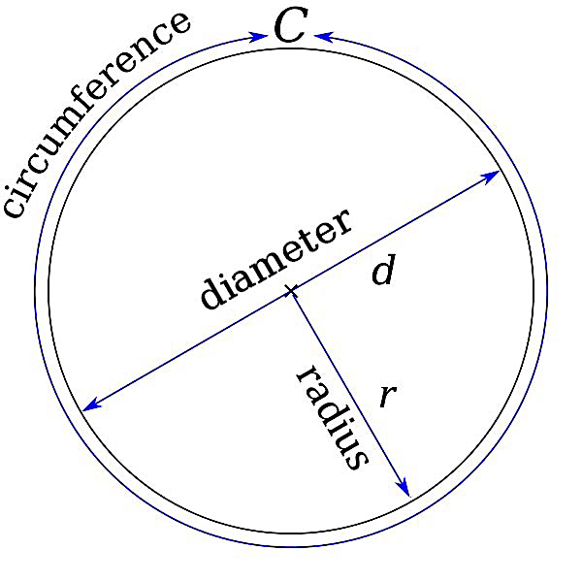

**Geometry Review – Right Triangles**

A right triangle is a triangle in which two sides are perpendicular, and thus form a right angle. The side opposite the right angle is often referred to as the **hypotenuse**, and the other two side are called the **legs**.

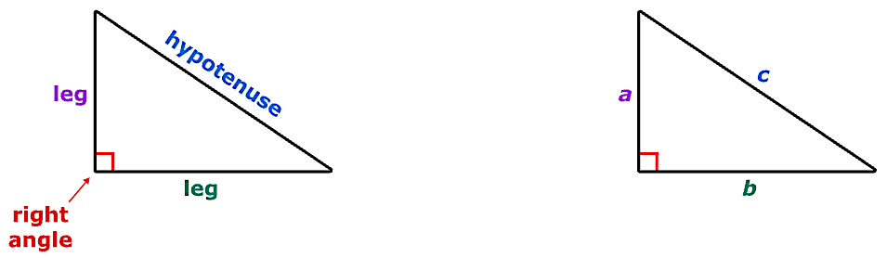

The Pythagorean theorem describes a special relationship between the three sides of any right triangle. The theorem states that the square of the hypotenuse is always equal to the sum of the squares of the legs (this can be proven using the distance formula). Using the notation from above:

$$a^{2}+b^{2}=c^{2}$$

Example 1: Determine the length of the missing side for the right triangles below.

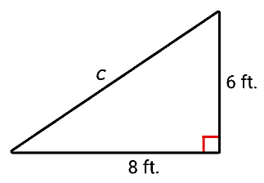 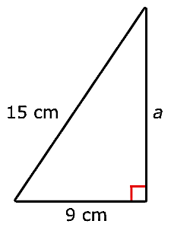

**Angles**

An **angle** is the union of two rays having a common endpoint. The endpoint is called the **vertex** of the angle, and the two rays are the sides of the angle. We start with two rays lying on top of one another. We leave one fixed in place, and rotate the other. The fixed ray is the **initial side,** and the rotated ray is the **terminal side**.

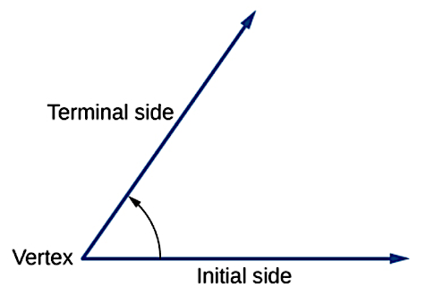

The **measure of an angle** is the amount of rotation from the initial side to the terminal side. Probably the most familiar unit of angle measurement is the degree. One **degree** is $\frac{1}{360}$ of a circular rotation, so a complete circular rotation contains 360 degrees.

To formalize our work, we will begin by drawing angles on a coordinate plane. Angles can occur in any position on the coordinate plane, but for the purpose of comparison, the convention is to illustrate them in the same position whenever possible. An angle is in **standard position** if its vertex is located at the origin, and its initial side extends along the positive $x$–axis.

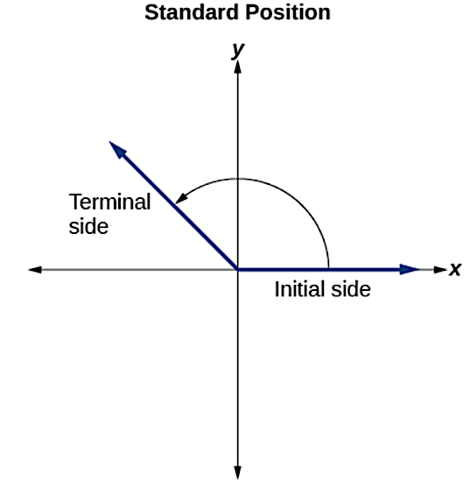

If the angle is measured in a counterclockwise direction from the initial side to the terminal side, the angle is said to be a **positive angle**. If the angle is measured in a clockwise direction, the angle is said to be a **negative angle**.

Drawing an angle in standard position always starts the same way—draw the initial side along the positive $x$–axis. To place the terminal side of the angle, we must calculate the fraction of a full rotation the angle represents. We do that by dividing the angle measure in degrees by 360°.

For example, to draw a $120°$ angle, we calculate that $\frac{120°}{360°}=\frac{1}{3}$, so the terminal side would be $\frac{1}{3}$ of the way around the circle moving counterclockwise from the positive $x$–axis.

The following Greek letters are commonly used as variables to represent angle measures.

|  |  |  |  |  |
| --- | --- | --- | --- | --- |
| $$θ$$ | $$α$$ | $$β$$ | $$ϕ \text{or} Φ$$ | $$γ$$ |
| Theta | Alpha | Beta | Phi | Gamma |

**Quadrantal Angles**

Since we define an angle in standard position by its initial side, when the terminal side lies on an axis it is known as a **quadrantal angle**. These angles do not have terminal sides that fall into one of the four quadrants.

**Radian Measure**

The circumference of a circle is $C=2πr$. If we divide both sides of this equation by $r$, we create the ratio of the circumference to the radius, which is always $2π$ regardless of the length of the radius. So the circumference of any circle is $2π≈6.28$ times the length of the radius. That means that if we took a string as long as the radius and used it to measure consecutive lengths around the circumference, there would be room for six full string-lengths and a little more than a quarter of a seventh.

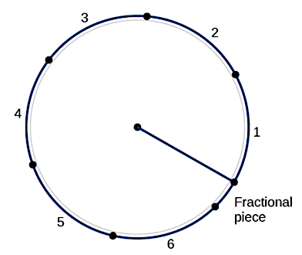

The **radian measure** of an angle is the **ratio** of the length $\left(s\right)$ of the arc subtended by the angle to the radius $\left(r\right)$ of the circle.

$$θ=\frac{s}{r}$$

Example 2: Draw sketches, in standard position, of the following angles.

 

$θ=300°$ $α=3$

**Converting between Degree and Radian Measure**

We now have two ways to discuss a full rotation around a circle, namely $360°$ and $2π$ radians. Combining these we arrive at our conversion factor:

$1 Rotation=360°=2π radians$ or equivalently $\frac{1}{2} Rotation=180°=π radians$

Example 3: Consider an angle measure of $1$ radian. How many degrees would this angle measure?

Example 4: Convert each angle measure from degrees to radians, or from radians to degrees.

$θ=150°$ $α=4$

$β=-120°$ $ϕ=\frac{3π}{7}$

**Coterminal Angles, $θ_{CT}$**

Coterminal angles are two angles in standard position with the same terminal side.

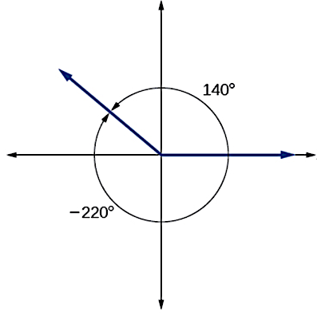

To find a coterminal angle between $0°$ and $360°$ (or between 0 and $2π$) add or subtract full rotations until the result is in the desired range.

Example 5: Determine the coterminal angle on the interval $0°<θ_{CT}<360°$ or $0<θ_{CT}<2π$.

$θ=800°$ $θ=\frac{18π}{5}$

$θ=-275°$ $θ=-\frac{23π}{7}$

**Reference Angle, $θ'$**

An angle’s **reference angle** is the size of the smallest acute angle, formed by the terminal side of the angle and the horizontal axis.

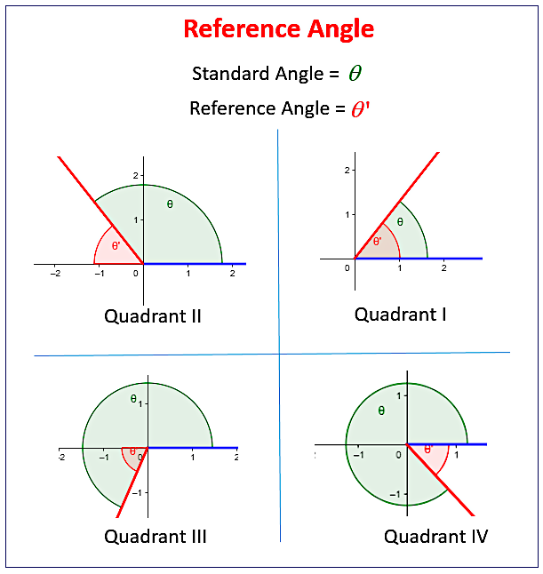

In Quadrant I: $θ^{'}=θ$

In Quadrant II: $θ^{'}=180°-θ$

$$θ^{'}=π-θ$$

In Quadrant III: $θ^{'}=θ-180°$

$$θ^{'}=θ-π$$

In Quadrant IV: $θ^{'}=360°-θ$

$$θ^{'}=2π-θ$$

Example 6: Determine the reference angle on the interval $0°<θ^{'}<90°$ or $0<θ'<\frac{π}{2}$

$θ=235°$ $θ=\frac{7π}{5}$

$θ=320°$ $θ=\frac{5π}{8}$

**Trigonometric Functions**

The trigonometric functions take angle measures as input and return a specific right triangle ratio. Since there are three sides to a right triangle, there are a total of six different ratios that can be built, and thus six different trigonometric functions.

For an angle $θ$ in standard position with a terminal side passing through the point $(x,y)$, we have:

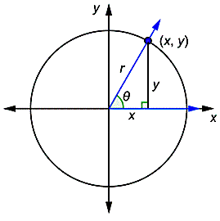

$\sin\left(θ\right)=\frac{y}{r}$ $\cos\left(θ\right)=\frac{x}{r}$ $\tan\left(θ\right)=\frac{y}{x}$

$$x^{2}+y^{2}=r^{2}$$

$\csc\left(θ\right)=\frac{r}{y}$ $\sec\left(θ\right)=\frac{r}{x}$ $\cot\left(θ\right)=\frac{x}{y}$

Example 7: Suppose the terminal side of an angle $θ$ in standard position passes through the point $\left(-1, \sqrt{3}\right).$ Evaluate the six trigonometric functions of $θ$. Visuals are incredibly helpful!

Example 8: Suppose $\csc\left(θ\right)=-2$ and $θ$ is in Quadrant IV. Evaluate the five remaining trigonometric functions of $θ$. Visuals are incredibly helpful!